Aim: - To study Basics of C language.

Objective: - To learn about printf, scanf, add etc.

Code: -



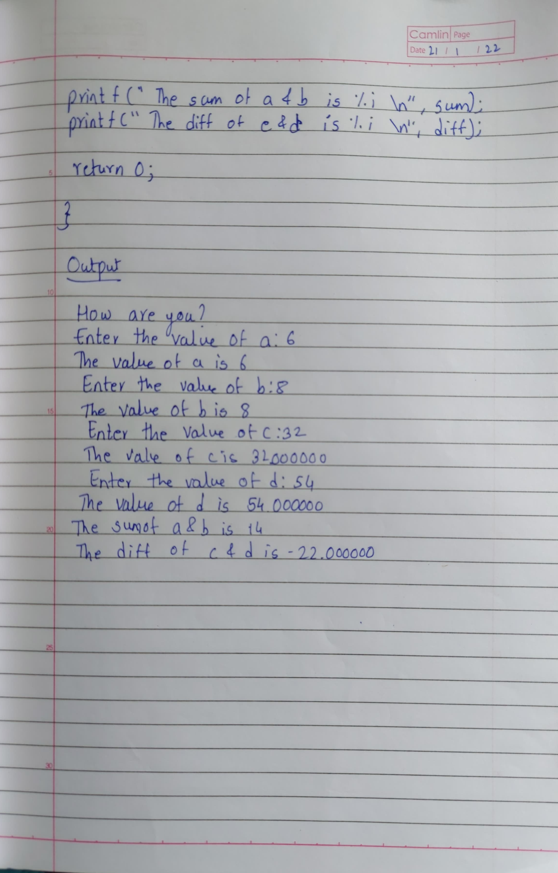Screenshot: -

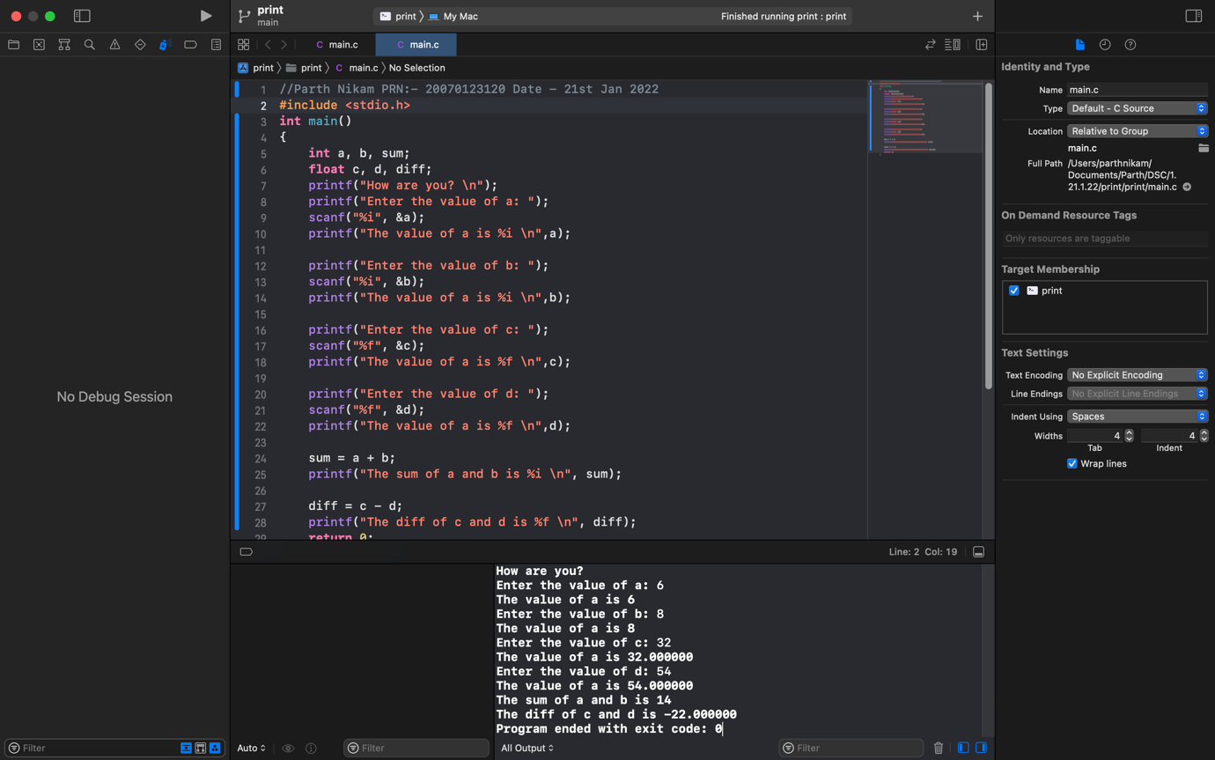

Result: - Basics of C language is studied successfully.